1. Make sure vscode and mysql workbench is installed and running on your system.
2. Install the necessary extensions in vscode to be able to connect with mysql.

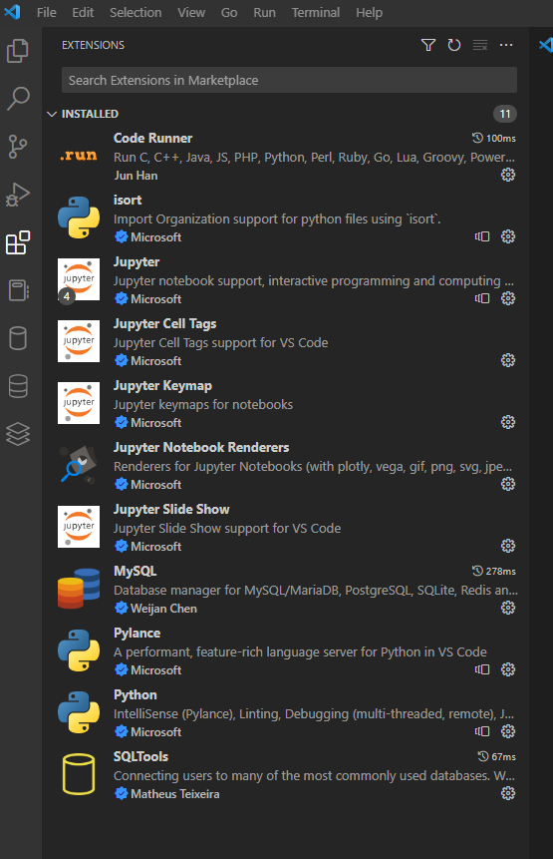

1. Open mysql workbench and try running a simple query like opening a table to ensure that mysql is working.

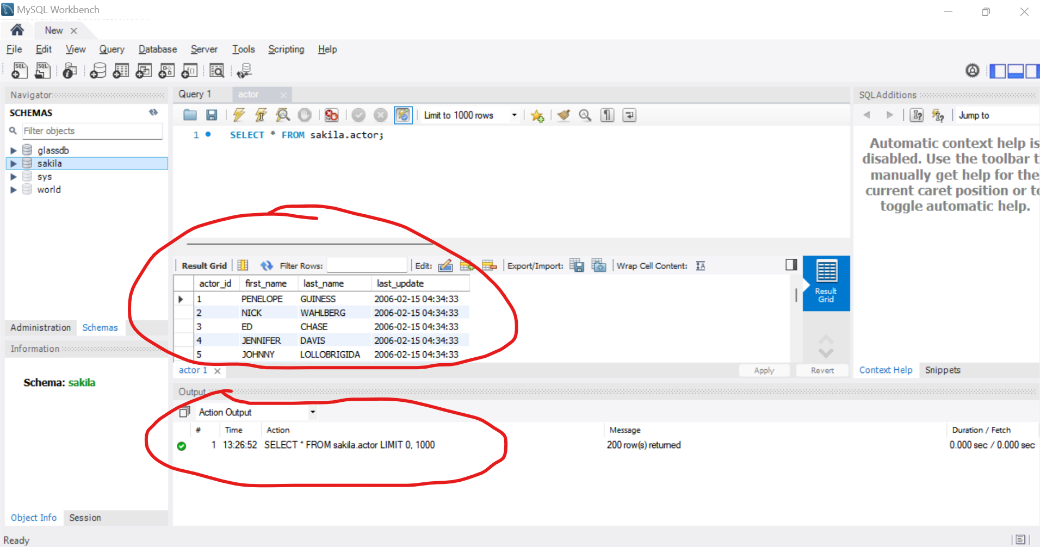

Results are displayed so we can confirm mysql is working fine.

1. Open vscode. If all the necessary extensions are installed your should be able to see a cylinder icon which is a database manager.

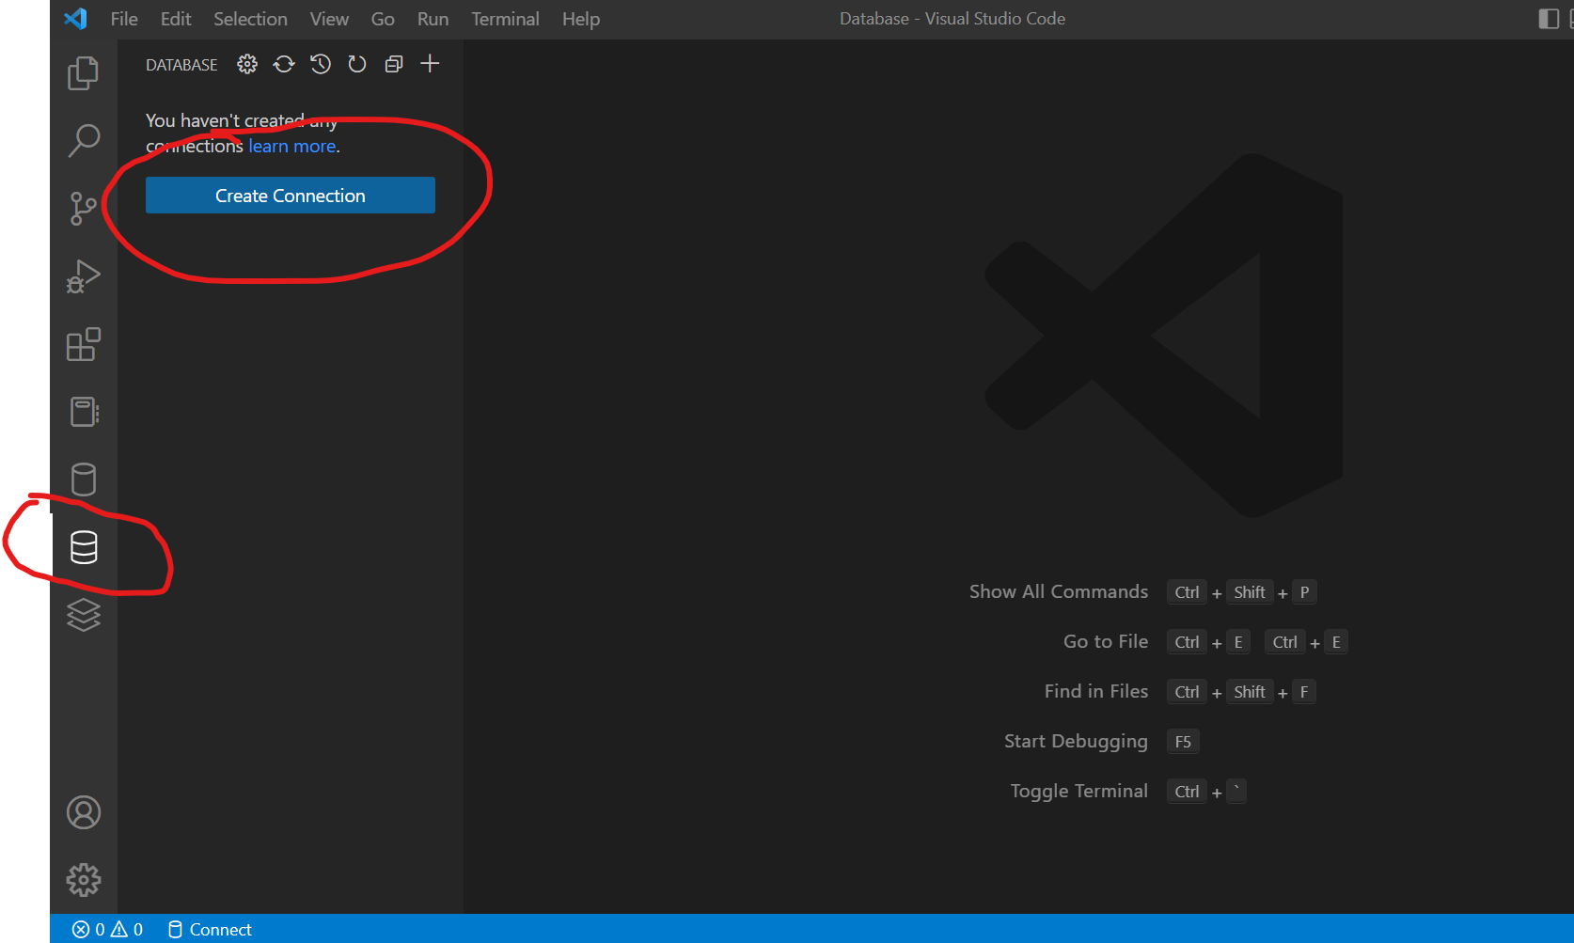

1. Click on create connection. Enter your local mysql workbench username (which is usually root) and password. No other info to be entered. Click connect upon entering the login details.

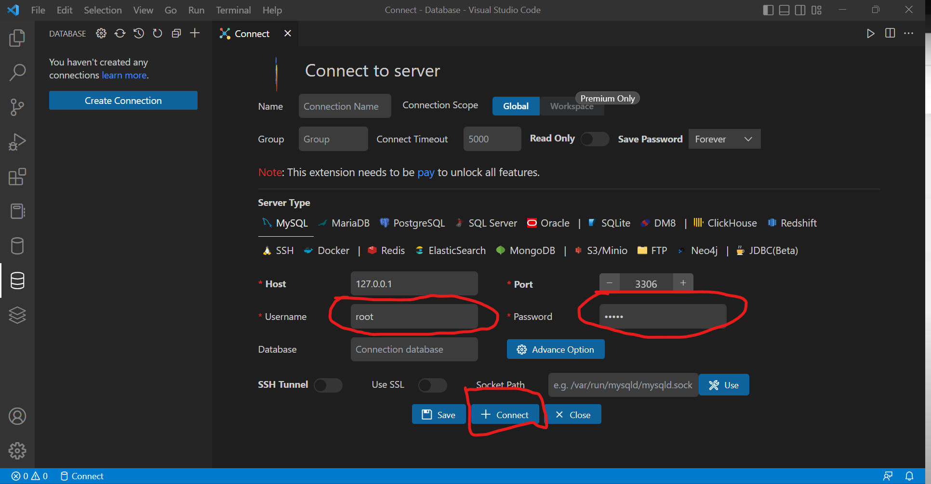

1. You should be able to see ‘Connect Success!’ Message.

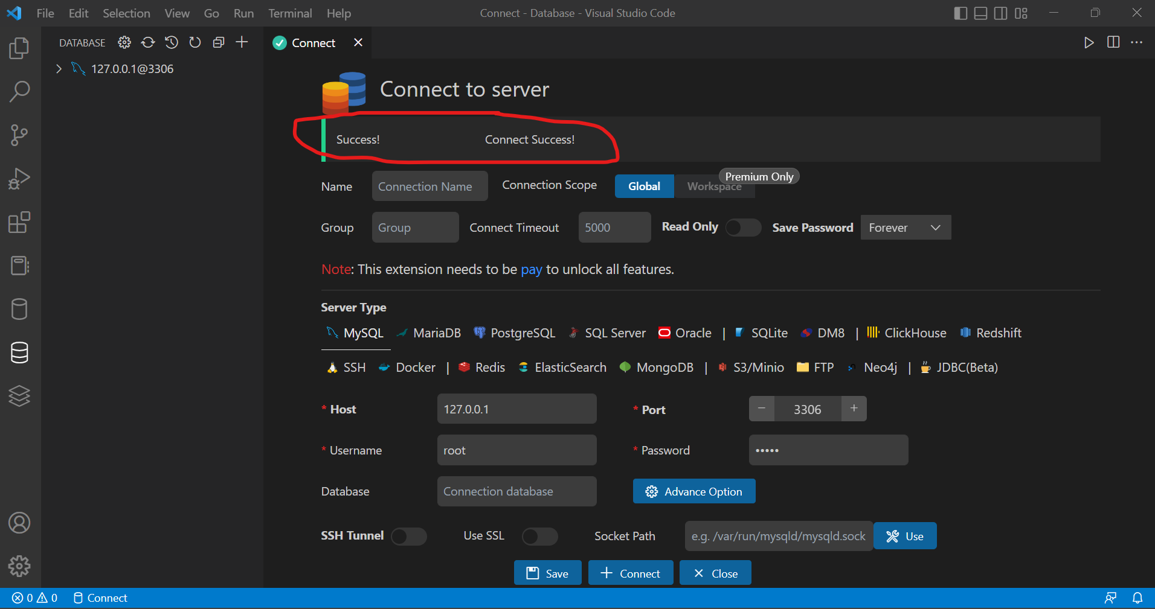

1. On the sidebar you should be able to see the databases available on your local mysql system. Click the dropdowns to explore.

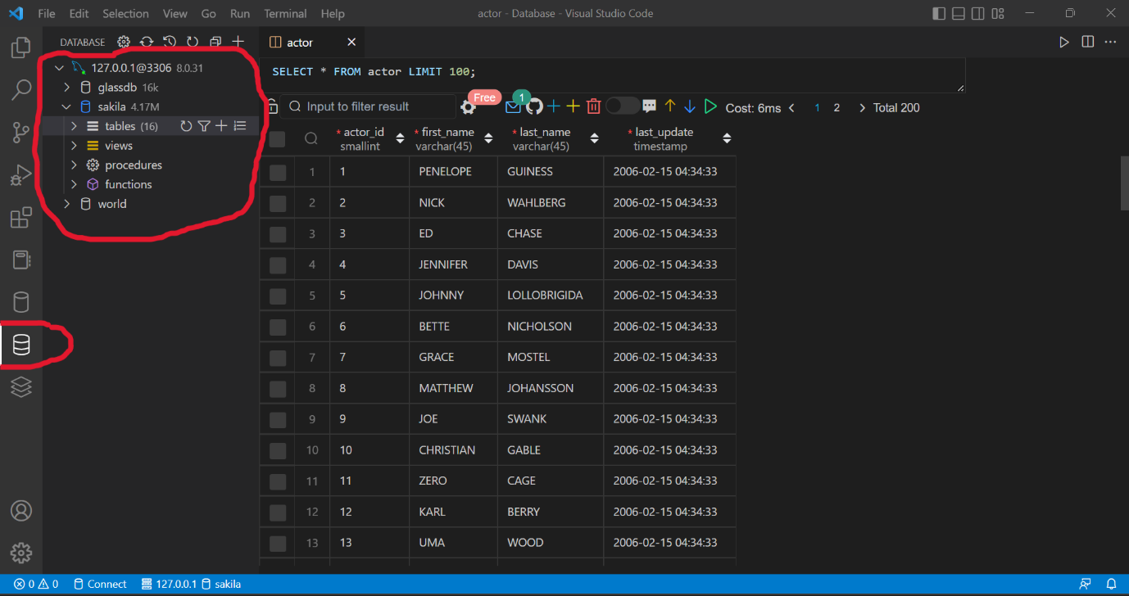

1. Click refresh button to be able to see any changes you make on the database/tables.

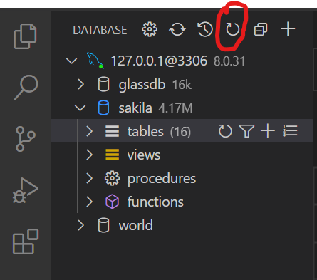

1. Once this connection is established you need not do this setup every time. It will be intact even if you vscode and mysql. Upon reopening you can still find your dbs and tables available.

Hope this helps!